VCOO Runbook – CAB review (04/07/2022)

Table of Contents

Document History 3
VCOO Components 4
Release Notes 4
Promotion to production runbook 5
DCP 5
Backup procedure 5
Deployment 5
Rollback 5
TDH platform 6
Backup procedure 6
Deployment 6
Rollback 6
TDH content 7
Backup procedure 7
Deployment 7
Rollback 8
Analytics APIs 9
Backup procedure 9
Deployment 9
Rollback 9
Infinity Frontend App 10
Backup procedure 10
Deployment 10
Rollback 10

Document History

Author | Version | Date
Carlos Lopez | 1.0 | 11.05.2022
Ionela Pirvu-Mitu | 1.1 | 12.05.2022

Comments:
This document has been updated with the relevant information by the owners of the respective segment (see below in the section the list of owners).

VCOO Components
This diagram shows the VCOO components that will be modified:

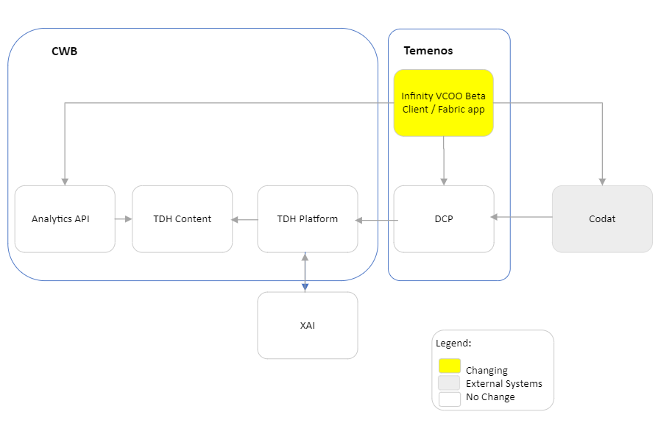

Release Notes

Component | Changes
DCP
TDH Platform
TDH Content
Analytics API
VCOO Application | - TSR 327840 - Index sorting for transaction data in fabric services  - TSR 340064 - Hiding images that are irrelevant to the selected accounting software provider

Promotion to production runbook

DCP
Owner: Carlos Lopes <clopes@temenos.com> / Sethupathi Sivasamy <ssethupathi@temenos.com>
Expected downtime:
Deployment Date and Time (MDT time zone):

Backup procedure

# | Task

Deployment

# | Task

Rollback

# | Task

TDH platform
Owner: Umesh Kadenahalli <umeshkm@temenos.com> / Rodrigo De Alba <rdealba@temenos.com>
Expected downtime:
Deployment Date and Time (MDT time zone):

Backup procedure

# | Task

Deployment

# | Task
1 | {Add text as appropriate}

Rollback

# | Task

TDH content
Owner: Kalin Todorov <ktodorov@temenos.com>
Expected downtime:
Deployment Date and Time (MDT time zone):

Backup procedure

# | Task

Deployment

# | Task

Rollback

# | Task

Analytics APIs
Owner: Kalin Todorov <ktodorov@temenos.com>
Expected downtime:
Deployment Date and Time (MDT time zone):

Backup procedure

# | Task

Deployment

# | Task

Rollback

# | Task

VCOO Frontend App
Owner: Chirevella Jahnavi <chjahnavi@temenos.com>
Expected downtime: 45 mins for fabric changes, 3hrs for front-end changes
Deployment Date and Time (MDT time zone): 5th July, 2022 8PM-12AM MST

Backup procedure
Take backup of Fabric apps, Web client VCOO, Spotlight and run time configurations of current environment.
Environment Deployment steps:
- Take backup of Fabric apps, Web client VCOO, Spotlight and run time configurations of current environment.
- Must decide reference environment to promote fabric apps and required details.
- Ready with the list of newly added server or client properties and add it to current Environment.
- Do the cleanup for required DB tables (Accounts, customer accounts …etc)
- Execute all DB queries related to VCOO
- Download Applicable Fabric apps to deploy on current new environment from reference ENV.
- Spotlight client app need to generate from actual Tag.
- Import Required Fabric apps and updated with Mule & Database & codat & analytics & okta urls.
- Upload VCOO & spotlight web clients with required versions and publish the app.

Required to update below details for fabric Applications once we import into production Environment:
DbpLocalServices:
- Update actual service endpoint url for DBXUserLogin identity and DBXAPIIdentityService.
- Required values for OktaOAuthIdentityProvider (below are the sample details, and we must update with our environment details)
- Authorize Endpoint : https://customer.cwbankgroup.com/oauth2/aus31tevzjvDFR0UH4x7/v1/authorize
- Token Endpoint: https://customer.cwbankgroup.com/oauth2/aus31tevzjvDFR0UH4x7/v1/token
- Logout Url: https://customer.cwbankgroup.com/oauth2/aus31tevzjvDFR0UH4x7/v1/logout
- Client ID : 0oa31tfjxeWHQT5GB4x7
- URL : https://customer.cwbankgroup.com/oauth2/aus31tevzjvDFR0UH4x7/v1/userinfo

- Enable HTTP Integrity Checking for this App from Identity -> service configuration (apply only if it is applicable for your current environment)

- Integration -> Customer ->service definition (These end point are sample endpoints and must update with your current environment endpoints)
- Change base url to : https://internal-integration.cwb.com/temenos-infinity/
- UserID: **************
- Password: ************
- Integration -> Accounts -> service definition (These end point are sample endpoints and must update with your current environment endpoints)
- Change base url to : https://internal-integration.cwb.com/temenos-infinity/
- UserID: ******************
- Password: *****************
- Integration -> dbpRbLocalServicesdb ->service definition (Provide respective Data base details)
- Database Connection URL: jdbc:mysql://cwb-prod-dbxdb.mysql.database.azure.com:3306?useSSL=true&requireSSL=true&verifyServerCertificate=false
- User ID: ************
- Password: ***********
- Integration-> Enrollment -> (These end point are sample endpoints and must update with your current environment endpoints)
- Change base url to : https://analyticsapi.prd-cc-xai.cwb.local/api/
- UserID: ***************
- Password: *****************
- Integration-> Holdings -> (These end point are sample endpoints and must update with your current environment endpoints)
- Change base url to : https://analyticsapi.prd-cc-xai.cwb.local/api/
- UserID: ***************
- Password: *****************
- Integration-> XAIModels -> (These end point are sample endpoints and must update with your current environment endpoints)
- Change base url to : https://analyticsapi.prd-cc-xai.cwb.local/api/
- UserID: ***************
- Password: *****************
- Integration-> codatIntegration -> (These end point are sample endpoints and must update with your current environment endpoints)
- Change base url to : https://api.codat.io/
- Integration-> connectionManager -> (These end point are sample endpoints and must update with your current environment endpoints)
- Change base url to : http://connectionsms.dcp-sme.svc.cluster.local:7014/ms-connections-api/api/
Note: Above mentioned end points and details are samples, so must change with actual endpoint of your current environment. Also, Mentioned above only few identity services, integration services and DB connections for understanding. It should be applicable for all identity services, and integration services (Mule services), analytics, codat and connection manager across all the fabric applications.

Deployment
# | Task
1 | Fabric Holdings API endpoint URLs need to be updated to incorporate the orderBy parameter:  Tenant1/DataQuery/VCOOBankTranBySubscriberByMonth?%24orderby=%22SortIndex%22%20&%24filter=%22Subscriber%22%3D%27$Subscriber%27  Publish the app after the above changes
2 | Deploy VCOO client application

Test Results:

Rollback
# | Task
1 | Deploy prior applications
2 | Unit test all API Endpoints
3 | Unit test the client application

